Brain Grenade

By Sarah McCormick

On Sunday, April 14, 2013 I woke up with a headache. This wasn’t unusual for me; I had battled chronic headaches and occasional migraines for over ten years. I had tried almost every available solution, but never found relief.
This headache was worse than normal, but since I had already made plans with my dad to hike the Manitou Springs Incline that day, I resorted to my usual option; suck it up, smile, and push through the pain. I got to my dad’s house and he could see in my eyes that my headache was getting worse. He offered up the option to go to Barnes & Noble, get a latte at Starbucks and look through travel magazines instead. I conceded because I was in pain, and also because this was another one of my favorite ways to spend time with him.
While flipping through pages of Conde Nast’s Traveler magazine with a chai tea latte in my hand, I felt a pain that I will not soon forget strike through my right eye and up through my skull. It felt like a white hot bolt of lightning electrocuting my brain. For Harry Potter fans out there, my Voldemort was close.
Hunched over in pain and grasping my head, my dad rushed me over to the nearest chair. The excruciating pain subsided, but left me really scared. That had never happened before. I told him that I needed to go home and find some migraine medication to take before it got worse. He offered to drive me home, but being as stubborn as I am, I told him I’d be fine driving myself. There were a few times on the drive back that my vision was altered, but that’s not something I wanted to admit to anyone, even myself.
Thinking it was just a severe migraine, I took some prescription migraine medication, crawled into bed and switched on Netflix…waiting for it to pass.

It never did. It only got worse…

I called in sick to work the next day and continued lying in bed with inadequate pain killers and trashy TV. I didn’t tell anyone about my lightning bolt pain or altered vision because I didn’t want to admit it was worse than my typical migraines. However, that afternoon the pain was so bad that I decided to go to the ER.
The ER staff put me in a dark room with a warm blanket and a lot of narcotics. That usually does the trick. Morphine and anti-nausea injections are the go-to solution for migraines. Adequately doped up, my mom and stepdad took me back home so the morphine hibernation could kick in and knock me --and my migraine -- out cold.
Hours of drugged and dreamless sleep passed, and I woke up only to increased pain and foggy consciousness, coupled with dehydration and weakness from skipping meals.
Without a lot of resistance or say in the matter, my parents took me back to the ER the next day. The doctors decided that a CT scan was the next step in figuring out my pain. I barely remember getting off my hospital bed and onto the CT table for the scan.
In addition to the CT scan and more narcotics, they also injected the base of my skull with a numbing agent like Novocain. Let me tell you, no matter how drugged and doped up you are from days of a steady stream of narcotics, hearing a needle and its contents being injected into the base of your skull right next to your ear, will wake you up with a searing certainty.
Back home I went, praying that this drug slumber would finally do the trick. Three more days passed without any relief; the pain didn’t let up, no matter how much medication my body consumed. Eventually, I couldn’t even keep food or water down without instantly getting sick. I couldn’t stand up without holding onto a wall or piece of furniture.
My worried parents called their primary care physician and explained the situation. I got an appointment with her that day and walked into her office like a brainless zombie. At that point, being a brainless zombie sounded quite appealing. The doctor asked my mom a few questions while I looked blankly at the wall. She scheduled an emergency MRI and within one hour, I was wearing an ugly medical gown lying inside a noisy, confining white tube as a machine snapped a picture of my brain.
We went back home and not long after I got settled on the couch with some of my mom’s chicken noodle soup, I received a call from the Radiologist telling me that I had a Cerebral Sinus Venous Thrombosis. (Say that five times fast!) In layman’s terms, I had a blood clot in my brain.

{A blood clot in my brain}

I was instructed to get up immediately and go directly to the hospital downtown. The radiologist already called and were expecting me. It was strange to think that I had reservations at a hospital. I had to go to the hospital downtown because that’s where the best brain surgeons in the city were. “Just in case something ‘bad’ were to happen,” the nurse said.
Despite that dramatic comment and the reality-shifting diagnosis, I was very calm. I thanked her, hung up and looked at my parents, explaining what I had just heard. I was relieved that I had an answer to what was causing this pain. My un-relenting lightning bolt brain pain might finally be coming to an end!
Everything started moving very quickly. My parents mobilized with military-like precision…feeding the dog, calling my grandparents, texting my brother, packing an overnight bag for me, wrapping me in a blanket and putting me in the car.
We got to the ER and I walked directly into a room they had waiting for me. VIP status baby! ;) A very handsome blonde doctor came in and explained that I needed to have another MRI with contrast this time so they could see the blood clot in more detail. This meant that I needed to get a special dye injected in my veins so the image was clear so they would know exactly where the clot was located.
A hot male nurse came in to the room and stuck a toothpick-sized needle in the biggest vein in the crease of my right arm. Of course McDreamy & McSteamy had to be my doctor and nurse while I looked like a brainless zombie with unwashed hair, zero makeup and hairy legs. But I guess life isn’t an episode of Grey’s Anatomy.
I was wheeled up to a room on the 4th floor of the hospital, where I was greeted by a sweet RN who hooked up a large bag of fluid to the IV tube in my right arm and told me that I would be on a heavy dose of Heparin, a blood thinning medication that would help reduce the size of the clot in my head.
As I was slowly adjusting to the smell of the sterility of my hospital room, the beeping of the machines connected to my bed, and the strange reality of being in the hospital, a doctor came in to explain what was happening.
Based on my age (28), coupled with the fact that I was a physically fit, active, non-smoker, the only viable reason why I was sitting in this room with a clot in my head was because of the birth control that I was on. This was happening because I switched my birth control method 4 months prior from the oral contraceptive, Yaz, to the vaginal ring, Nuvaring. The reason why I switched 4 months earlier? I heard commercials on TV about women who were hurt using Yaz/Yasmin and how they could be eligible for compensation in class-action lawsuits. Oh the irony…
I had to immediately remove the Nuvaring and was told by my doctor I would never again be allowed to use hormonal contraceptive methods. My future pregnancies may even be high-risk and I would have to be heavily monitored once I got pregnant. She told me that I would have to stay in the hospital for 5 more days while they pumped a high-dose of Heparin through my veins to prevent further clotting or a possible stroke. I would then go on an oral blood thinner named Coumadin for 6 months once I got out of the hospital to further shrink the clot. No surgery would be needed, thank God.
The next 5 days were filled with the highs of family and friends visiting, sending flowers and showing love, the lows of self-pity, frustration and cabin fever, as well as the strange experiences that naturally occur from staying in a hospital room for that long.
One of strangest had to be sleeping on a bed that was meant for someone who was more at risk for bed sores than I was. The bed was constantly shifting my weight around by filling with air in different places. It was like an air mattress pump came on every few minutes, making it practically impossible to sleep. Once I did finally go to sleep (with the help of Ambien) a nurse would come in and wake me up every 4 hours to check my blood levels. I would hide from the bright lights underneath my blanket while she poked my fingertips and squeezed blood into vials.
Showering was a whole other story. My room didn’t have a shower, so my nurse told me I could use one that was down the hall. I rolled my IV stand down the hallway, only to find basically a broom closet with a shower in it. I had to hold my right arm out of the shower because my IV couldn’t get wet. All I wanted to do was shave my legs, but razors were a definitely no-no with blood almost as thin as mine.
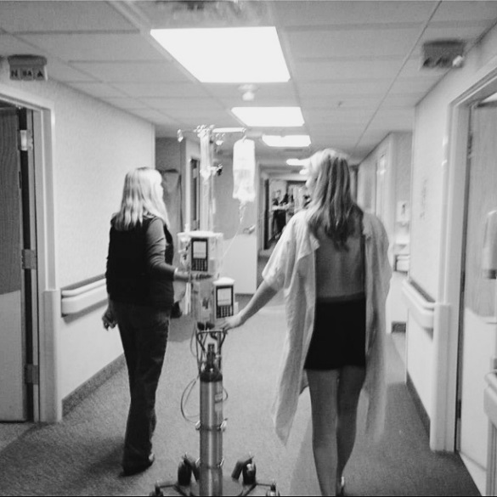
Heading to the hallway shower.
While list of repercussions of being on Nuvaring for 4 months continued to grow, so did my gratitude for finding this clot when I did. I know many women were not as lucky as I was and suffered through strokes and long-term health defeats. Some women even lost their lives.
I made it through the following six months with as much grace as I could muster. But there definitely were times when I was annoyed that I had to wear an ugly medical alert bracelet in case of emergencies, that I was covered in bruises from my blood being so thin, and that I had to go to the Coumadin clinic every week to get my finger pricked to check my blood. I felt defeated and ashamed as my body awkwardly readjusted to getting off hormonal birth control by gaining weight and breaking out in acne that I thought I had happily left back in 8th grade. Even now, I still get worried and anxious when thinking about what I’ll have to go through once I get pregnant.
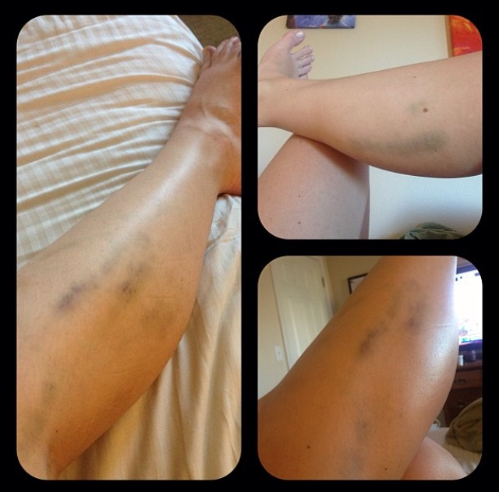
Bruises everywhere!
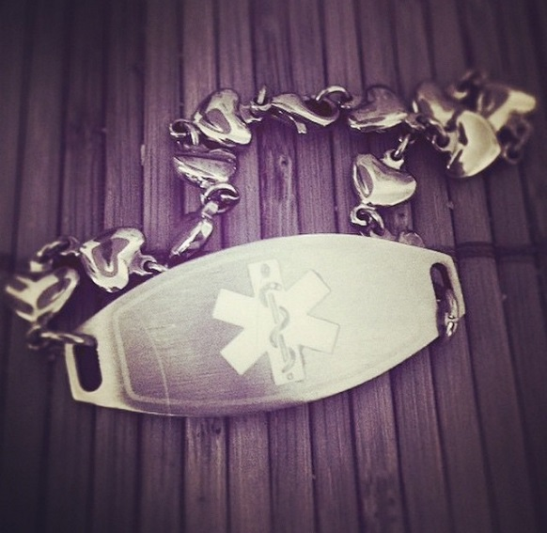
Medical alert bracelet

But even with all of that, I count my lucky stars that this is in the past, that I’m healthy and happy, and that I can share my story with other women, to hopefully help them think through their options, know the risks of Nuvaring and realize there are other ways of taking care of themselves and their family.

